Saw Mill Run Integrated Watershed Management Plan

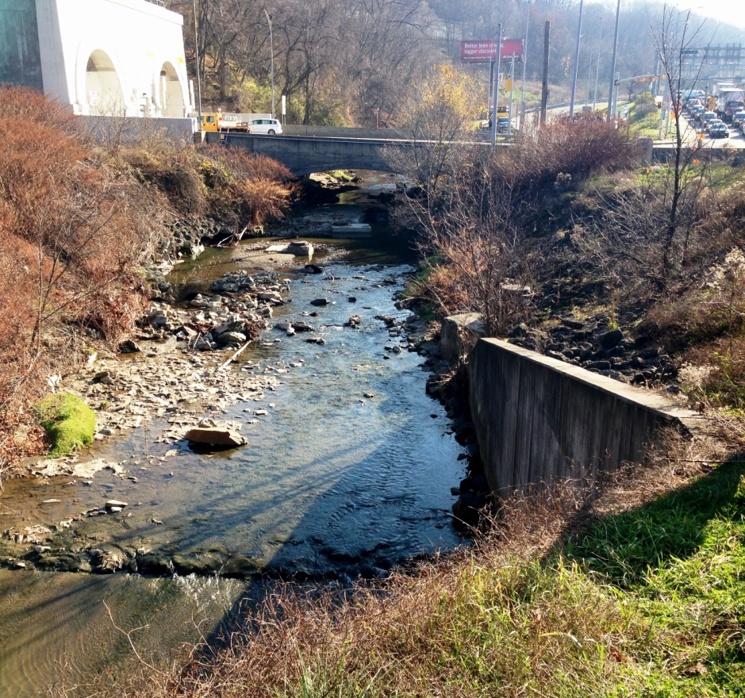Photo by: Katherine Camp

Saw Mill Run Watershed Background
Located in Allegheny County, Pennsylvania, the Saw Mill Run Watershed is approximately 19 square miles and encompasses all or part of 12 separate and diverse municipalities including 14 City of Pittsburgh neighborhoods. The watershed is dominated by Route 51, a major corridor into the City of Pittsburgh, which follows the stream for most of its way. The valley's steep slopes, the high density of impervious surfaces and the stream's close proximity to the highway lead to frequent flooding along the stream channel. Flooding and nonpoint source pollution have been major problems for more than 50 years along the stream and its tributaries. These issues have not only had a negative impact on water quality in the stream, but have also contributed to disinvestment extending into the adjacent communities and neighborhoods.

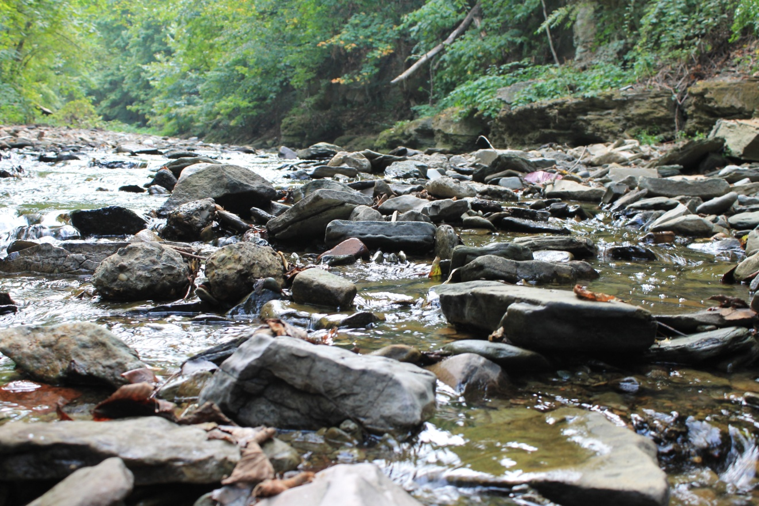Photo by Lisa Brown

Saw Mill Run Integrated Watershed Management plan (IWM)
Initiated by the Pittsburgh Water and Sewer Authority, and facilitated by the Saw Mill Run Watershed Association, the Saw Mill Run IWM plan will collaboratively identify the most cost-effective solutions to meet the stream's water quality goals, using a data-driven approach. Economic Development South (EDS) is PWSA's community partner, and has played a key role in assembling the Saw Mill Run watershed's municipal stakeholders. Once the planning process is complete, the plan will leverage municipal capital improvement investments to improve water quality and positively impact the lives of some 70,000 residents across City of Pittsburgh neighborhoods and the 11 adjacent municipalities.

Saw Mill Run IWM Plan Goals

The Saw Mill Run Watershed planning and implementation efforts are about defining a long-term strategy for green infrastructure (GI) investments while creating long-lasting community benefits. When fully implemented, the projects outlined in the IWM plan will improve the water quality in Saw Mill Run, reconnect the stream to its floodplain and riparian habitat, create much needed access to the stream to engage citizens with this natural asset, and increase green space to reduce flooding and sewage overflows.
GI will help accomplish the vision of a Green Boulevard along Saw Mill Run. It will create and improve natural habitat for birds, amphibians, fish and other wildlife, and reduce the impact of the urban heat island effect and carbon emissions from vehicles traveling Route 51. Looking beyond the typical GI investments, like bioswales and rain gardens, the team would like to identify how improvements like bicycle / pedestrian trails, recreational amenities, and park improvements could be integrated into this implementation strategy.
A network of thoroughly documented demonstration projects throughout the watershed will show how we can resolve stormwater issues by concentration efforts upstream to avert downstream overflows. In time, the team anticipates this intervention will provide job, research, and water management opportunities as well as green infrastructure education and continued community engagement.
Another goal of this project is to demonstrate the effectiveness of the IWM approach to stormwater remediation and inform a similar process in the remaining watersheds in the Pittsburgh region.

Municipalities in the Saw Mill Run Watershed
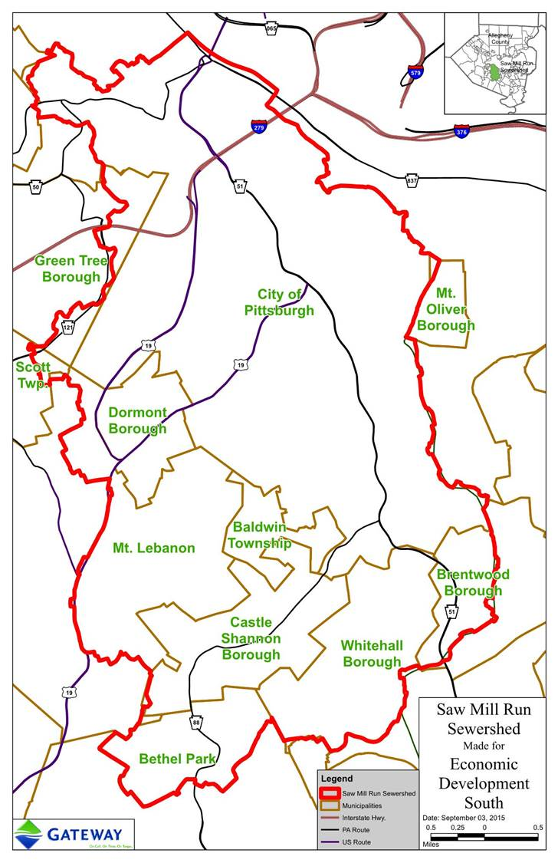

City of Pittsburgh
Brentwood Borough
Whitehall Borough
Dormont Borough
Mt. Lebanon Borough
Castle Shannon Borough
Bethel Park Borough
Baldwin Township
Green Tree Borough
Scott Township
Mount Oliver Borough
Crafton Borough

Partners
Economic Development South GTECH
Saw Mill run Watershed Association 12 Municipalities
Pittsburgh Water and Sewer Authority R.K. Mellon foundation
Allegheny County Sanitary Authority (ALCOSAN) U.S. Army Corps of Engineers

Process
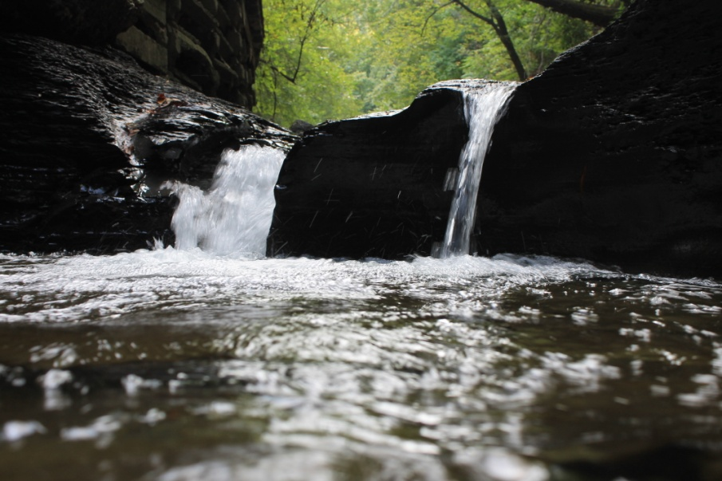

Photo by Lisa Brown
2013
- Saw Mill Run watershed is identified by regional stakeholders as an ideal place to demonstrate an IWM approach.
- PWSA includes this strategy in its Wet Weather Feasibility Study, outlining a path to Clean Water Act compliance.
2014
- PWSA hires consultants to begin the IWM planning process and develops a formal partnership with Economic Development South.
- Team participates in Sustainable Cities Design Academy.
2015
- A monthly technical working group is established for municipal engineers and other watershed leaders.
- The meeting fosters communication among policy developers, engineers, and elected officials.
- The technical working group shares critical data on an ongoing basis to develop the IWM plan.
2016
- Flow monitors are installed in sewer and sewer outfalls at multiple locations in the watershed.
- U.S. Army Corps of Engineers carries out in-stream hydraulic modeling, to complement the hydrologic models being developed by the PWSA team. These will eventually be combined to develop a water quality model that can be used to assess the water quality benefits of potential projects.
- The team collects a series of water quality samples in multiple areas of the stream in both wet weather and dry weather.
- The PA Department of Environmental Protection conducts biological monitoring in Saw Mill Run. The low numbers of fish and macro invertebrates indicate the water quality is very impaired.
2017
- Once the data collection and modeling phases are complete, the next major tasks are to determine the appropriate level of control for each pollutant, and then to develop the list of projects required to meet that level of control.
- Projects will be prioritized according to water quality impact, community benefits, and cost effectiveness.
If you have additional questions about GI, please contact us atgreeninfrastructure@pgh2o.com.

